Software and driver installation steps

Arduino Compile software installation
"2. Software development folder is opened, the two versions, a is 0023 version, this version is not installed, are copied to the C drive" arduino-0023 "folder or D disk root directory.
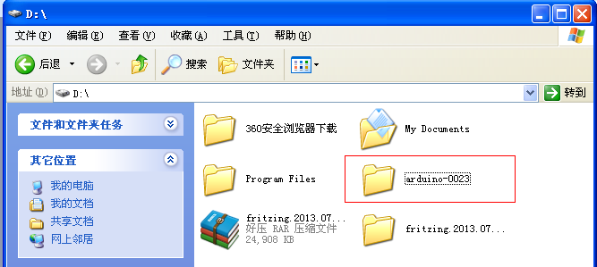
And then open it：
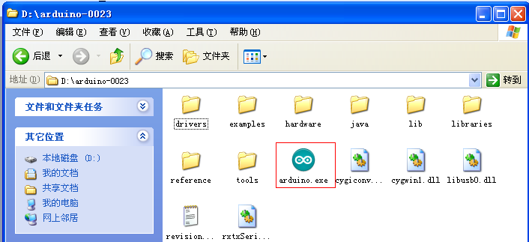
Click Arduino.exe and then right mouse button, choose to send to the desktop shortcut.
After installation, the software can be used. The following is the open look:
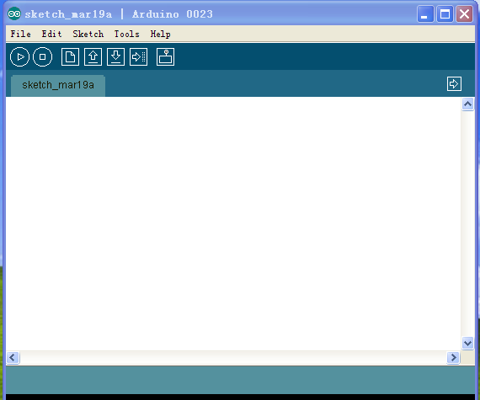
Below is the installation method of Arduino1.5.6：
Open the 2 software development folder under the Arduino-1.5.6 folder of the latest version of "double click the Arduino-1.5.6.Exe file。
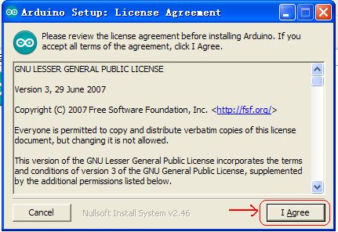
Then：
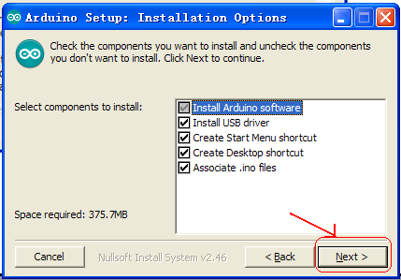
Then：
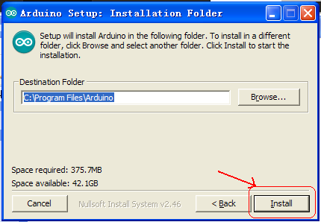
Wait for the installation to complete. Click close to complete the installation.

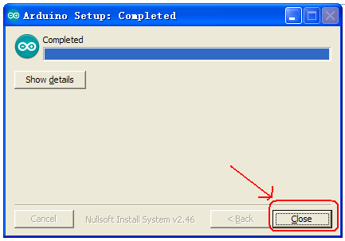
1.5.6 version after the installation of the appearance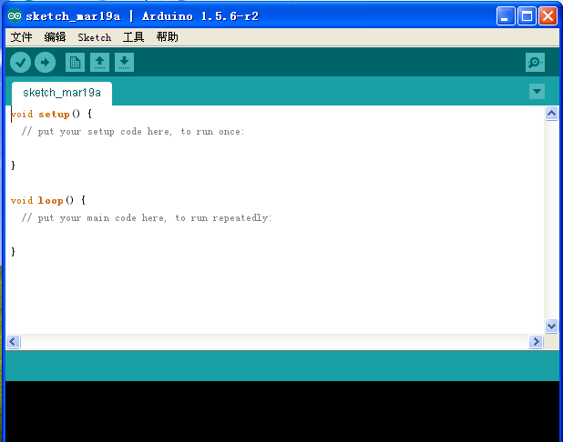

Next is the installation of the Arduino board driver.

